Experiment No. 1
Generation and Classification of Continuous-Time and Discrete-Time Signals
OBJECTIVE:
(i) To generate and visualize basic continuous-time signals such as unit step, unit impulse,
ramp, sinusoidal, and exponential signals.
(ii) To generate and visualize basic discrete-time signals and analyze their amplitude and time-
index characteristics.
(iii) To generate and classify continuous-time and discrete-time signals as periodic or aperiodic
based on their periodicity characteristics.
(iv) To decompose a given signal into its even and odd components and verify the
reconstruction of the original signal.

(i) To generate and visualize basic continuous-time signals such as unit step, unit impulse,
ramp, sinusoidal, and exponential signals.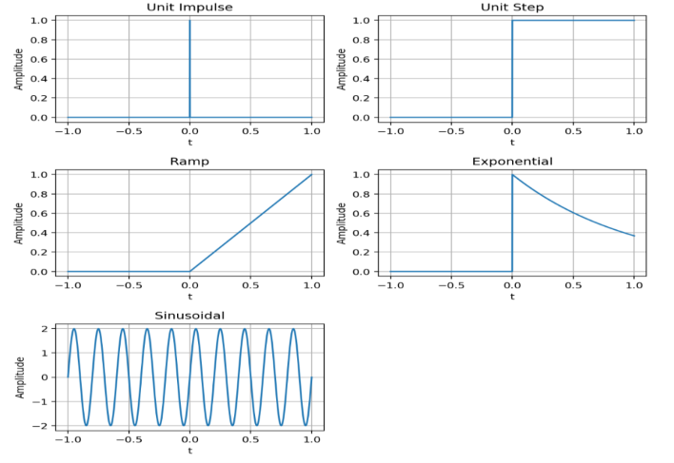

ii) To generate and visualize basic discrete-time signals and analyze their amplitude and
time-index characteristics.
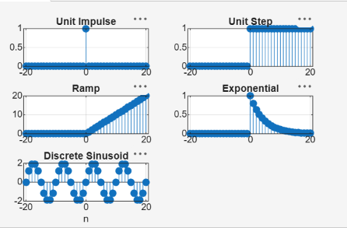

(iii) To generate and classify continuous-time and discrete-time signals as periodic or
aperiodic based on their periodicity characteristics.

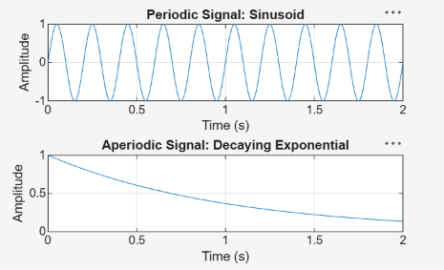

(iv) To decompose a given signal into its even and odd components and verify the reconstruction of the original signal.
